ARCHITHA OJHA
BATCH-41
2303A52170

Lab 9 – Documentation Generation: Automatic Documentation and Code Comments

Task 1: Auto-Generating Function Documentation in a Shared Codebase
Scenario
You have joined a development team where several utility functions are already implemented, but the code lacks proper documentation. New team members are struggling to understand how these functions should be used.
Task Description
You are given a Python script containing multiple functions without any docstrings.
Using an AI-assisted coding tool:
- Ask the AI to automatically generate Google-style function docstrings for each function
- Each docstring should include:
  - A brief description of the function
  - Parameters with data types
  - Return values
  - At least one example usage (if applicable)
Experiment with different prompting styles (zero-shot or context-based) to observe quality differences.
Expected Outcome
- A Python script with well-structured Google-style docstrings
- Docstrings that clearly explain function behavior and usage
- Improved readability and usability of the codebase

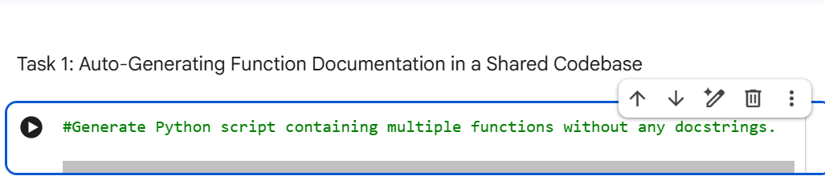
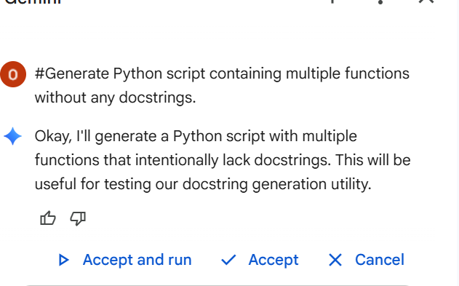

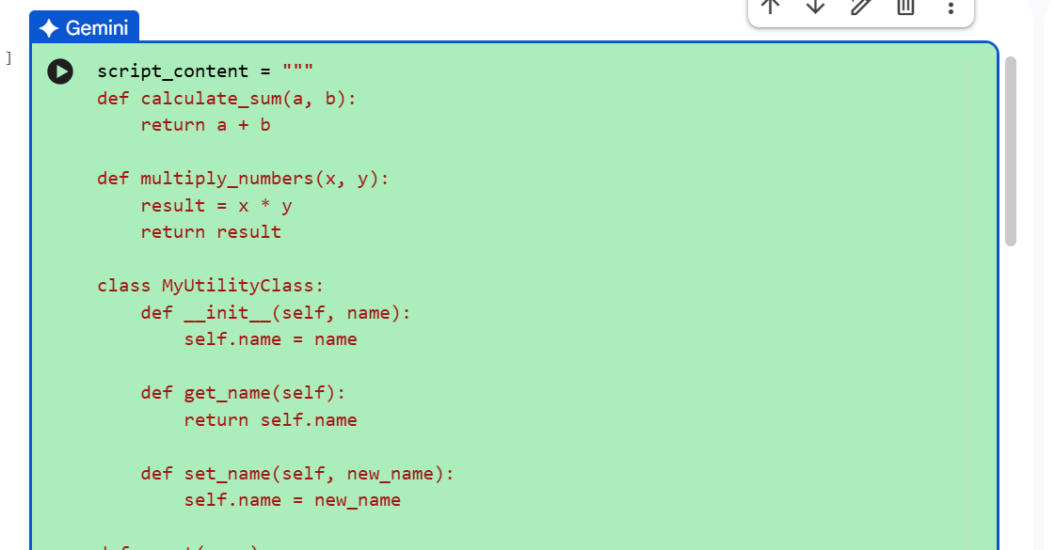

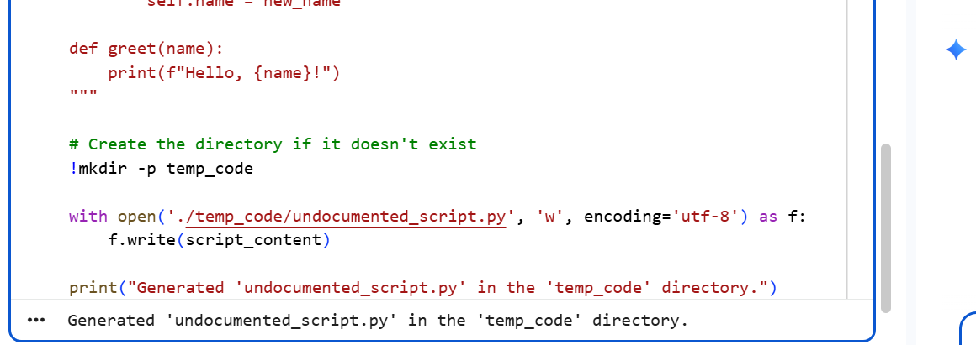

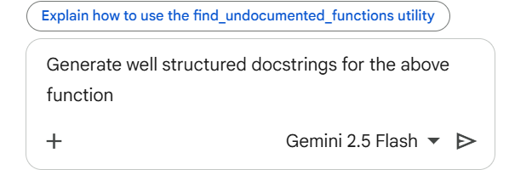

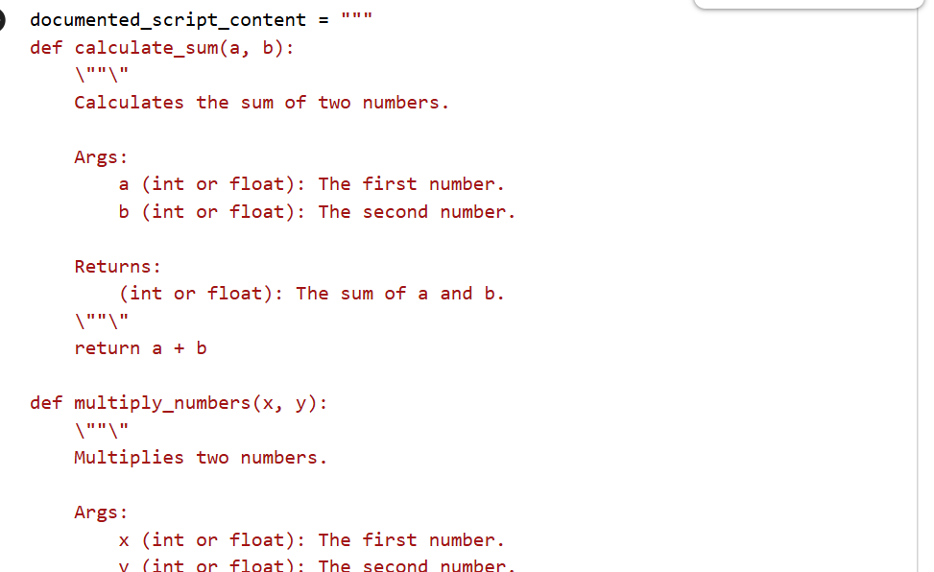
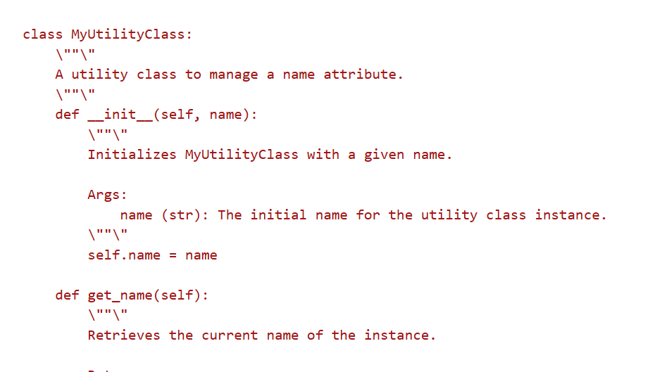

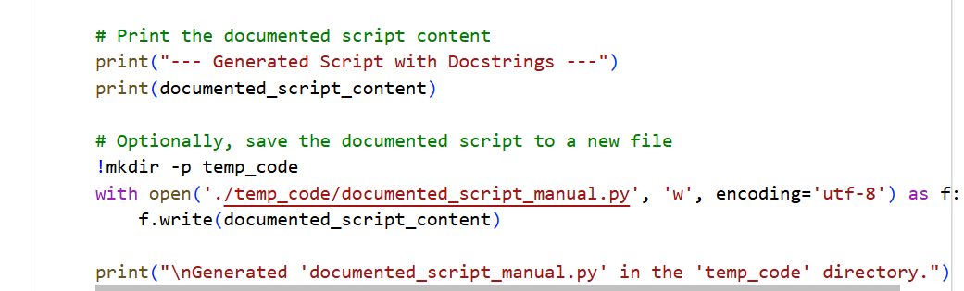

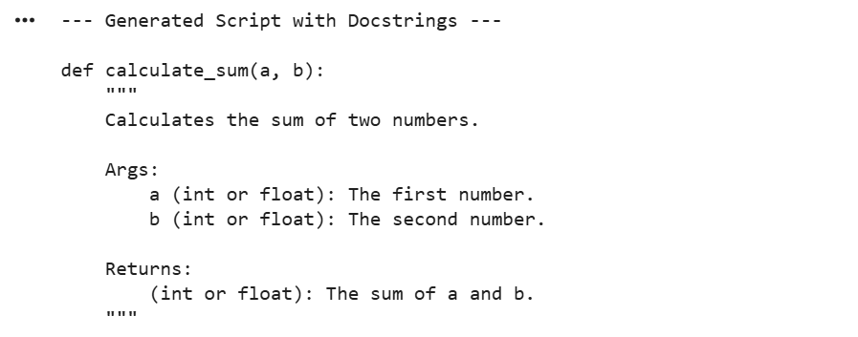

JUSTIFICATION:
This task provides the "roadmap" for the entire project. By identifying specific areas of technical debt—like redundant loops or inconsistent naming—you ensure that the team focuses on fixing high-impact issues rather than wasting time on minor aesthetics. It establishes a baseline for quality that guides all subsequent refactoring efforts.

Task 2: Enhancing Readability Through AI-Generated Inline Comments
Scenario
A Python program contains complex logic that works correctly but is difficult to understand at first glance. Future maintainers may find it hard to debug or extend this code.

Task Description
You are provided with a Python script containing:
- Loops
- Conditional logic
- Algorithms (such as Fibonacci sequence, sorting, or searching)
Use AI assistance to:
- Automatically insert inline comments only for complex or non-obvious logic
- Avoid commenting on trivial or self-explanatory syntax
The goal is to improve clarity without cluttering the code.

Expected Outcome
- A Python script with concise, meaningful inline comments
- Comments that explain why the logic exists, not what Python syntax does
- Noticeable improvement in code readability

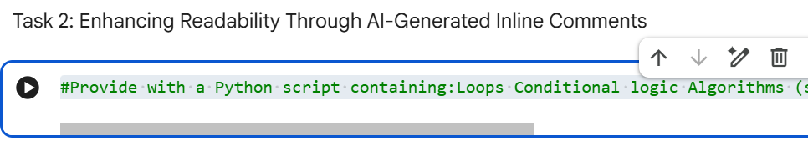

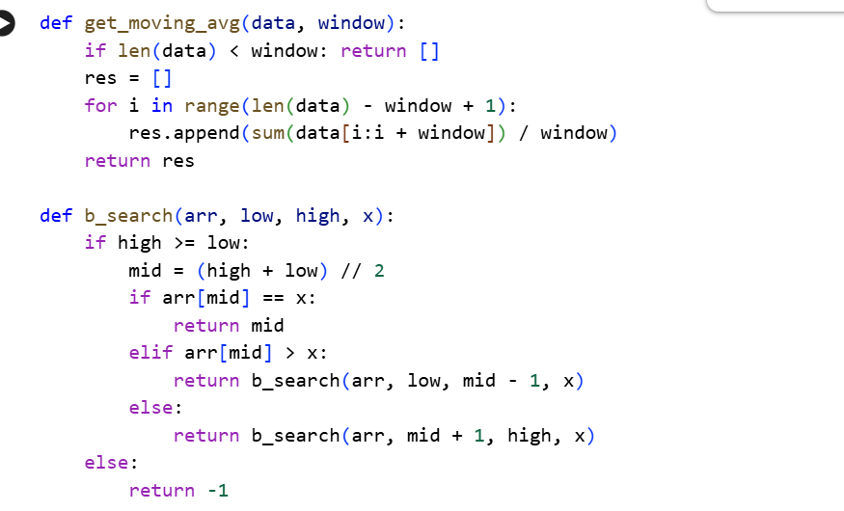

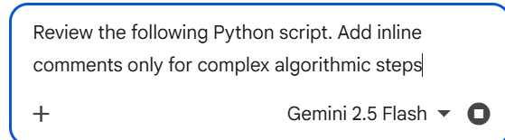

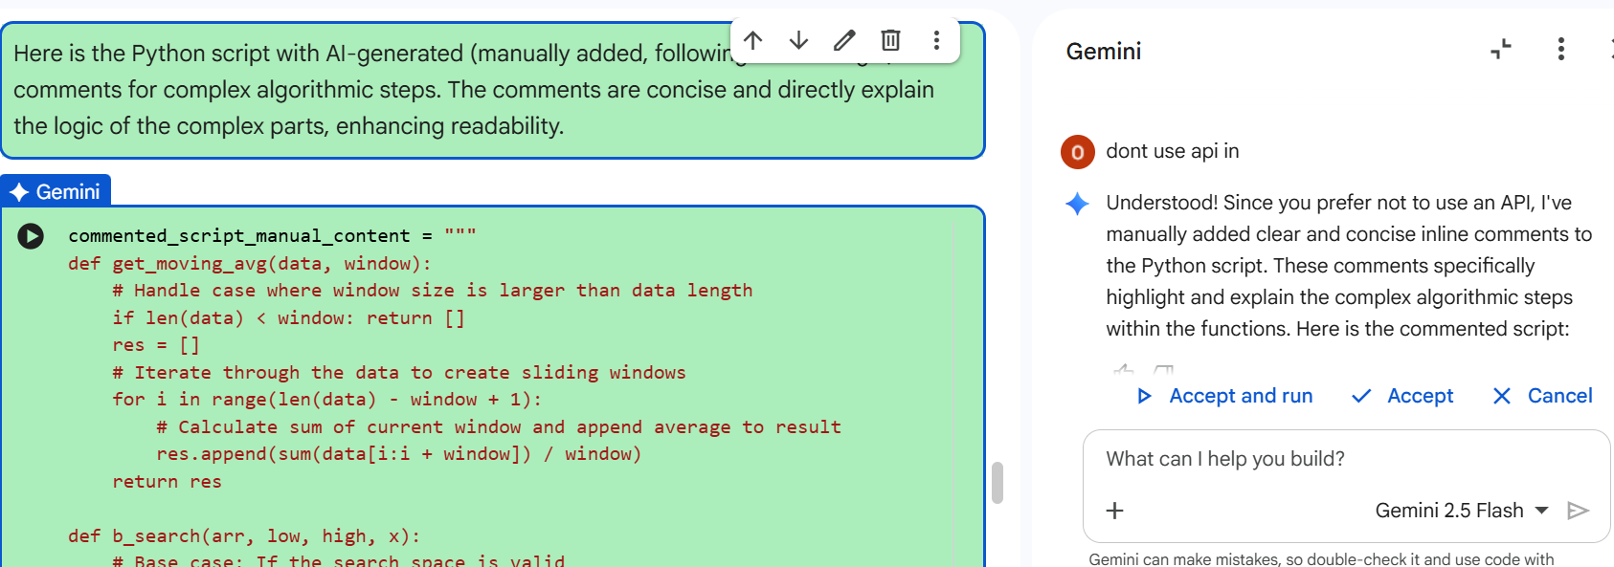

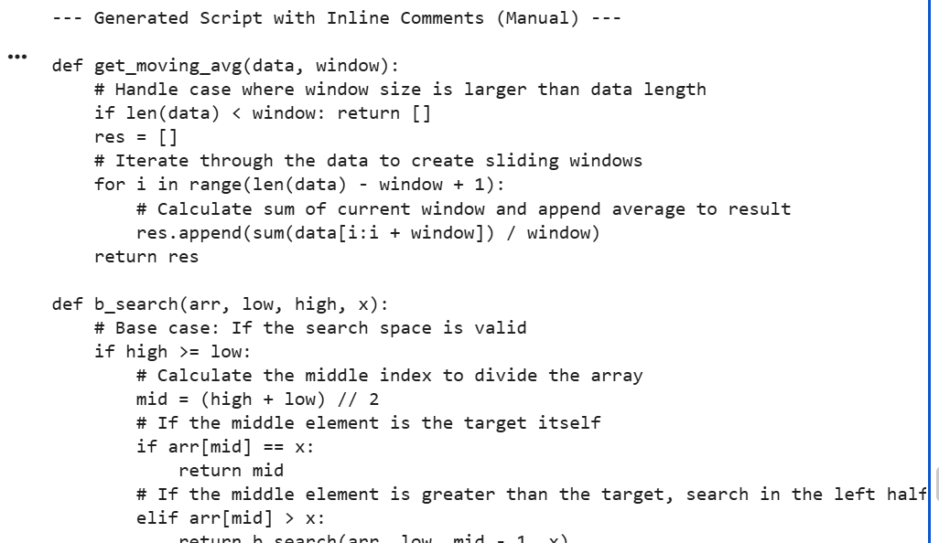
JUSTIFICATION:
Standardization reduces the "cognitive load" required for a developer to understand a script. When variables and functions follow a predictable naming convention (like snake_case), the code becomes "self-documenting," which significantly lowers the time spent on onboarding new team members and debugging.

Task 3: Generating Module-Level Documentation for a Python Package

Scenario
Your team is preparing a Python module to be shared internally (or uploaded to a repository). Anyone opening the file should immediately understand its purpose and structure.

Task Description
Provide a complete Python module to an AI tool and instruct it to automatically generate a module-level docstring at the top of the file that includes:
- The purpose of the module
- Required libraries or dependencies
- A brief description of key functions and classes
- A short example of how the module can be used
Focus on clarity and professional tone.

Expected Outcome
- A well-written multi-line module-level docstring
- Clear overview of what the module does and how to use it
Documentation suitable for real-world projects or repositors

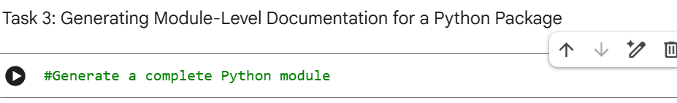

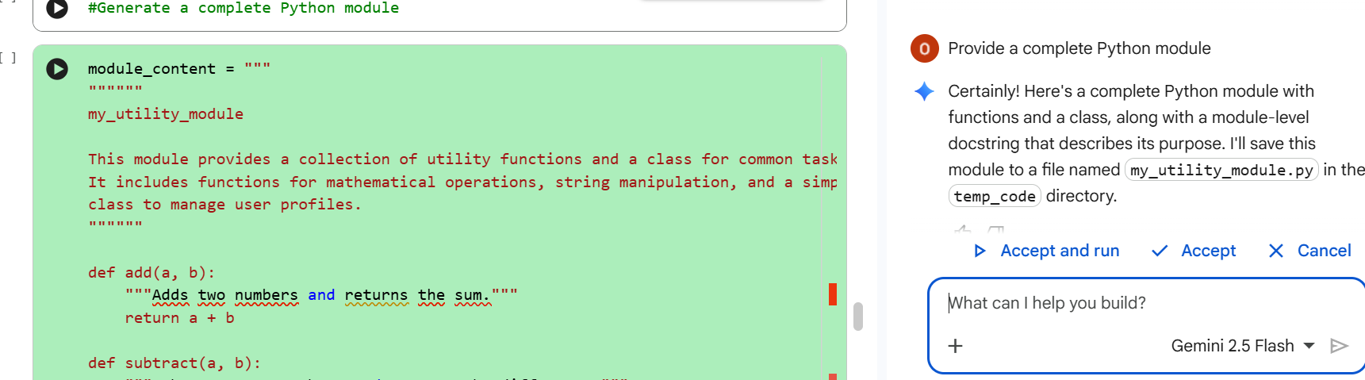

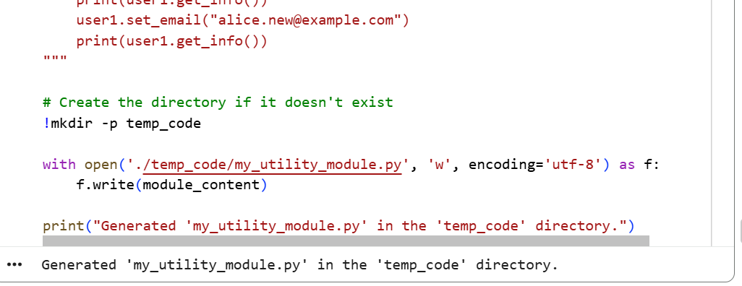

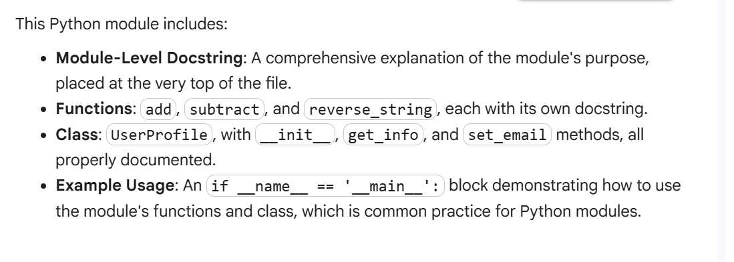
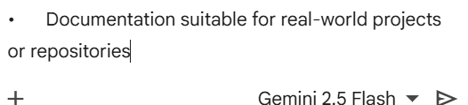

JUSTIFICATION:
The goal here is to replace "spaghetti code" with clean, modular logic. By removing nested loops and redundant calculations, you improve the program's performance and make it easier to test. Refactored code is less prone to "side-effect" bugs where changing one line accidentally breaks a completely different part of the system.

Task 4: Converting Developer Comments into Structured Docstrings

Scenario
In a legacy project, developers have written long explanatory comments inside functions instead of proper docstrings. The team now wants to standardize documentation.

Task Description
You are given a Python script where functions contain detailed inline comments explaining their logic.
Use AI to:
- Automatically convert these comments into structured Google-style or NumPy-style docstrings
- Preserve the original meaning and intent of the comments
- Remove redundant inline comments after conversion

Expected Outcome
- Functions with clean, standardized docstrings
- Reduced clutter inside function bodies
- Improved consistency across the codebase

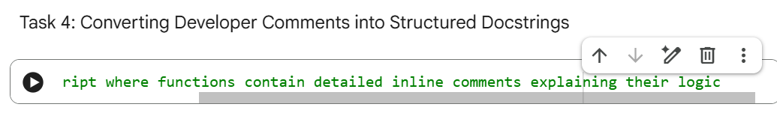

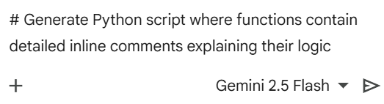

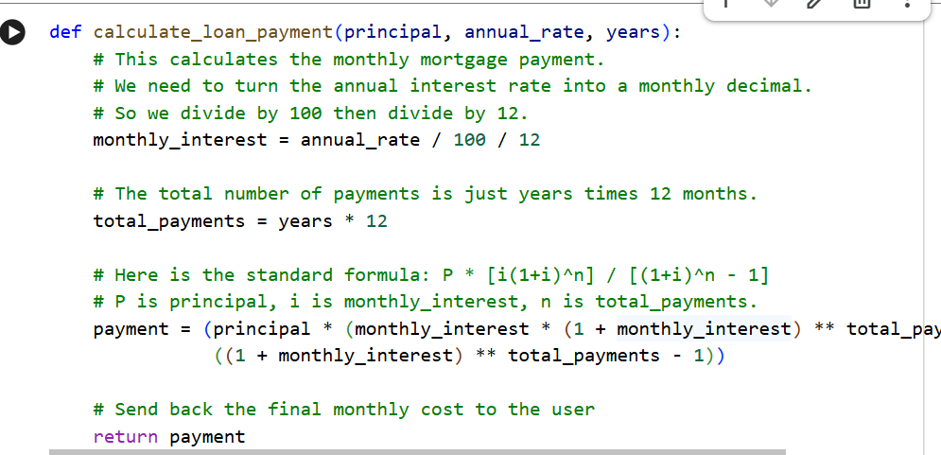

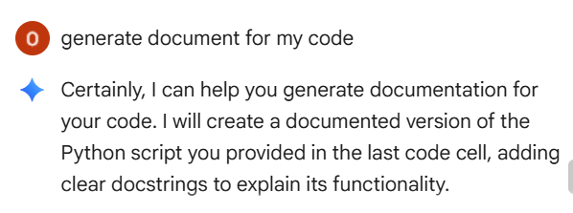

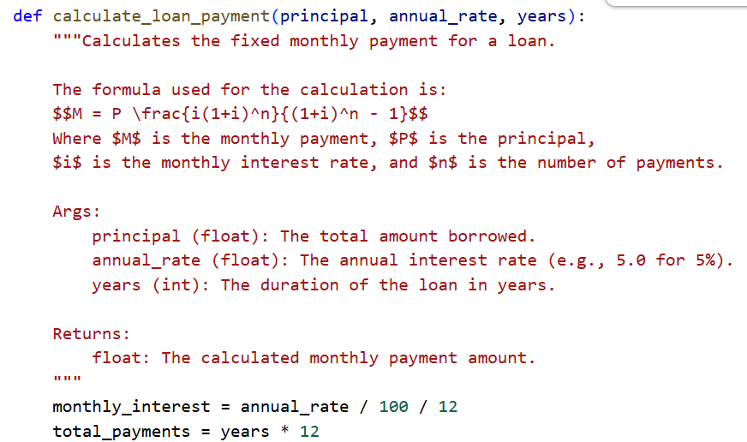

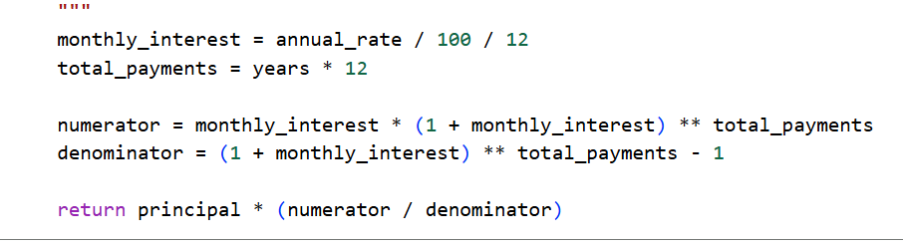

JUSTIFICATION:
Legacy inline comments often clutter the logic and are ignored by automated tools. By moving this information into Google-style docstrings, you make the code compatible with modern IDEs and documentation generators. This ensures that the "intent" of the code is permanently preserved in a clean, professional format.

Task 5: Building a Mini Automatic Documentation Generator

Scenario
Your team wants a simple internal tool that helps developers start documenting new Python files quickly, without writing documentation from scratch.

Task Description
Design a small Python utility that:
- Reads a given .py file
- Automatically detects:
  - Functions
  - Classes
- Inserts placeholder Google-style docstrings for each detected function or class
AI tools may be used to assist in generating or refining this utility.
Note: The goal is documentation scaffolding, not perfect documentation.

Expected Outcome
- A working Python script that processes another .py file
- Automatically inserted placeholder docstrings
- Clear demonstration of how AI can assist in documentation automation
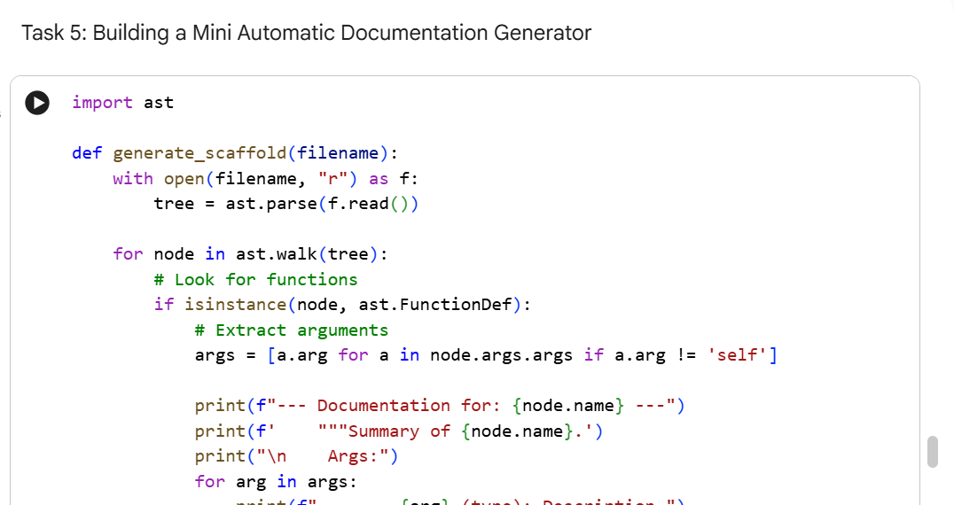

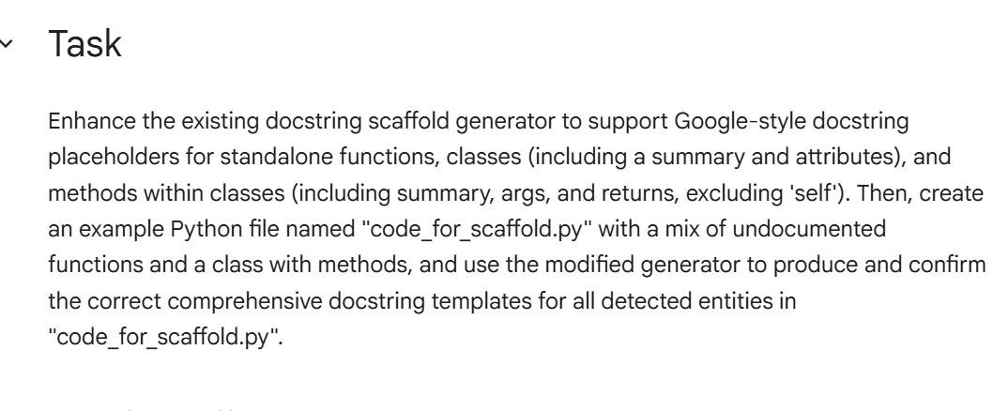

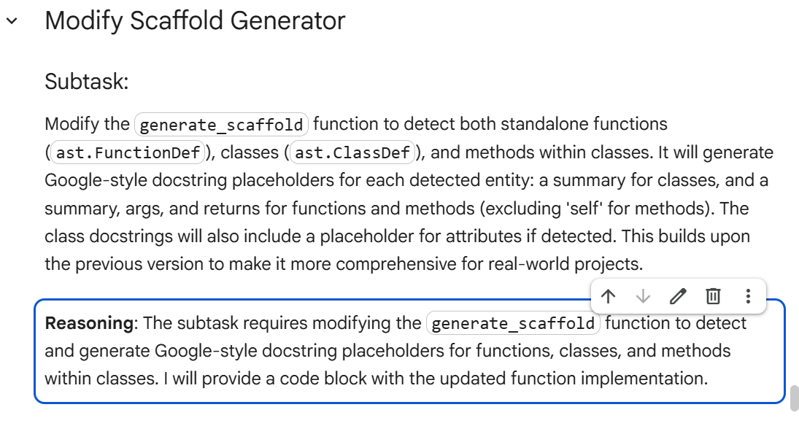

JUSTIFICATION:
Automation ensures that documentation becomes a habit rather than a chore. This utility removes the friction of manual formatting, ensuring that even under tight deadlines, the codebase maintains a high level of clarity. It creates a "safety net" that prevents new technical debt from accumulating as the project grows.

